Task 3: Parallel Feature Development
- Branch Creation: Create two branches, master_1 and master_2, from the main branch.
- Feature Development in master_1: Create a To-Do Page in the frontend with a form containing the fields Item Name and Item Description.
- Backend API in master_2: Create a backend route named /submittodoitem that accepts itemName and itemDescription via a POST request and stores these details in a MongoDB database.
- Merging Changes: Merge the changes from both master_1 and master_2 into the main branch.

Created the master_1 and master_2 branches.
Git branch “branch name” : command to create branch.
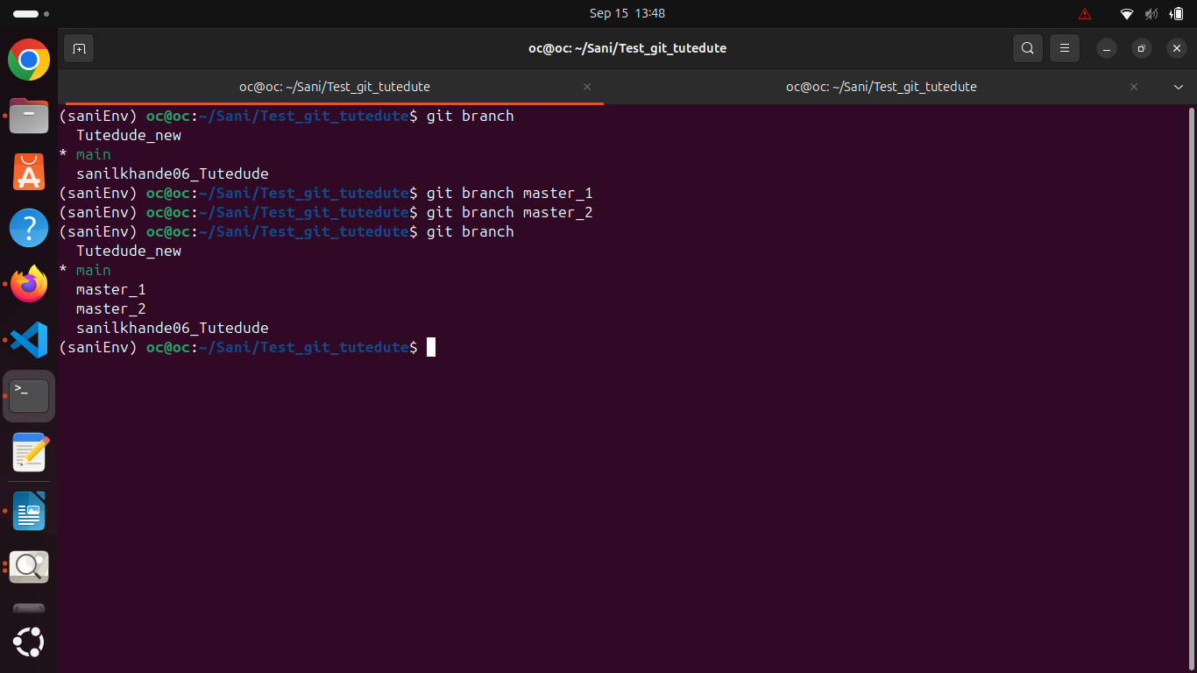

Ran frontend on master_1
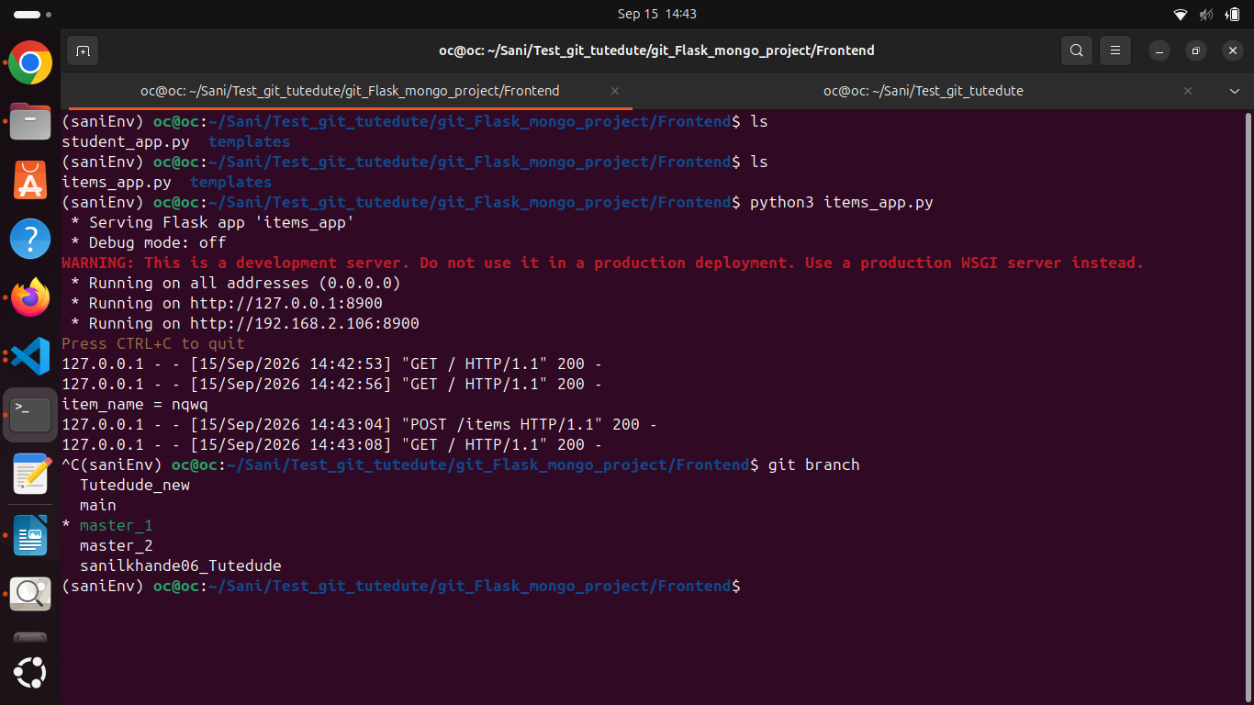
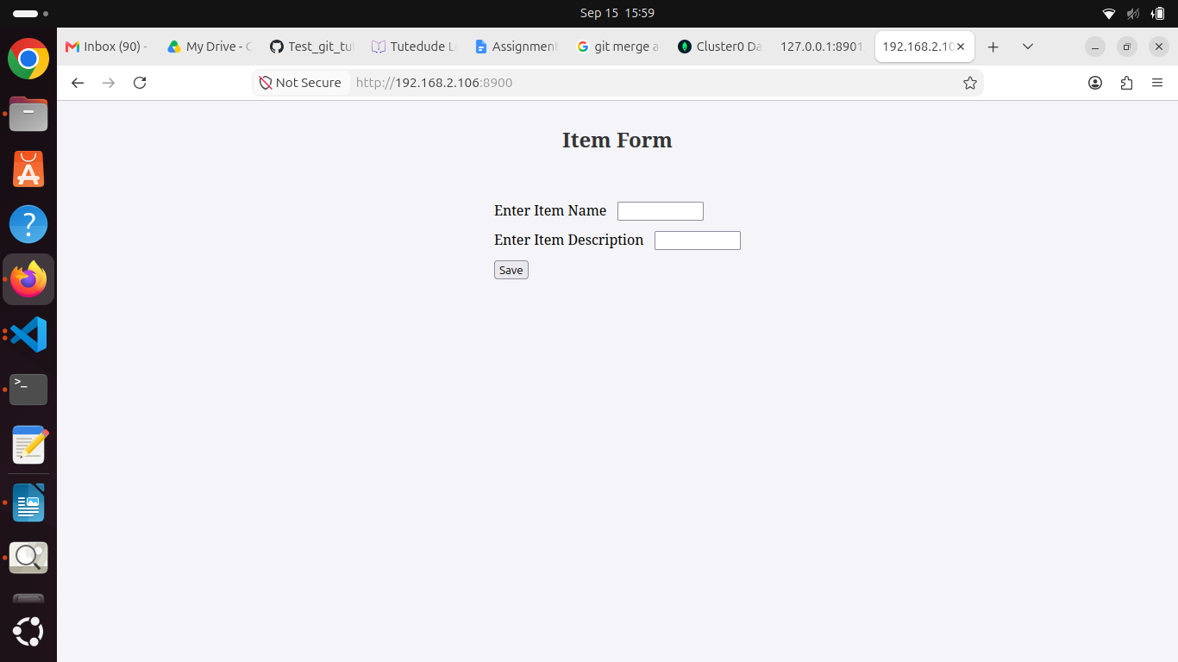

Committed the changes of master_1 and checkout to master_2 branch
git status : check the staged or untagged files
git add : used to add untagged files
git commit : to commit the changes
git checkout : used to switch to another branch.
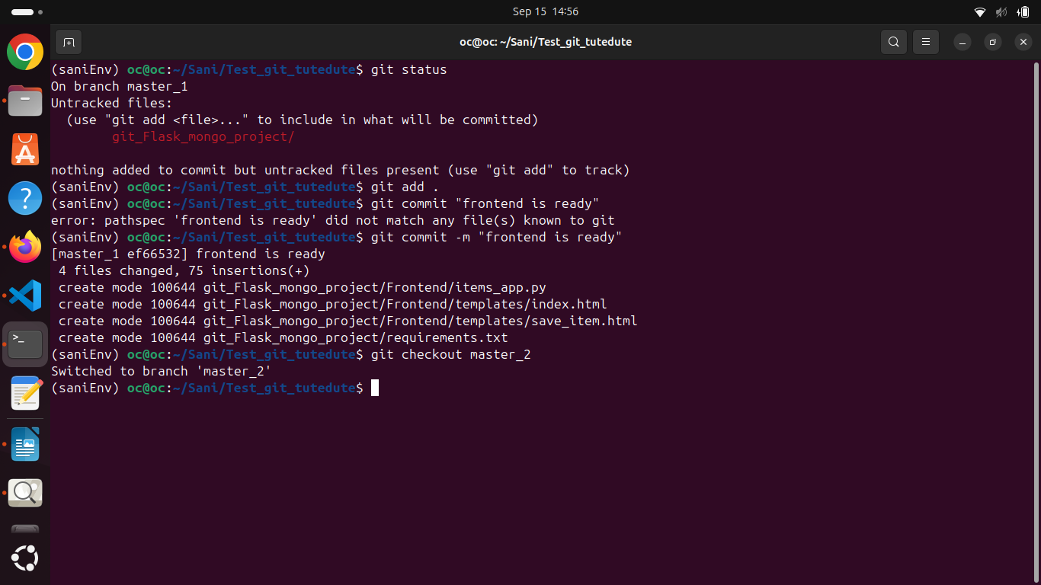

Listing the all branches :
git branch : used to list all branches
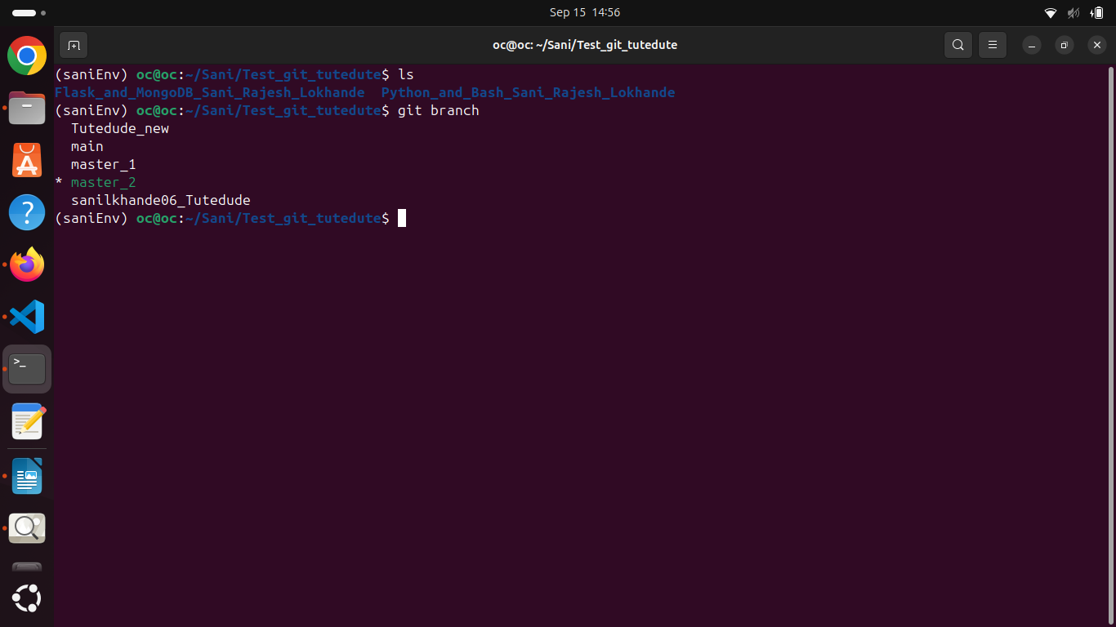
Running the backend list items
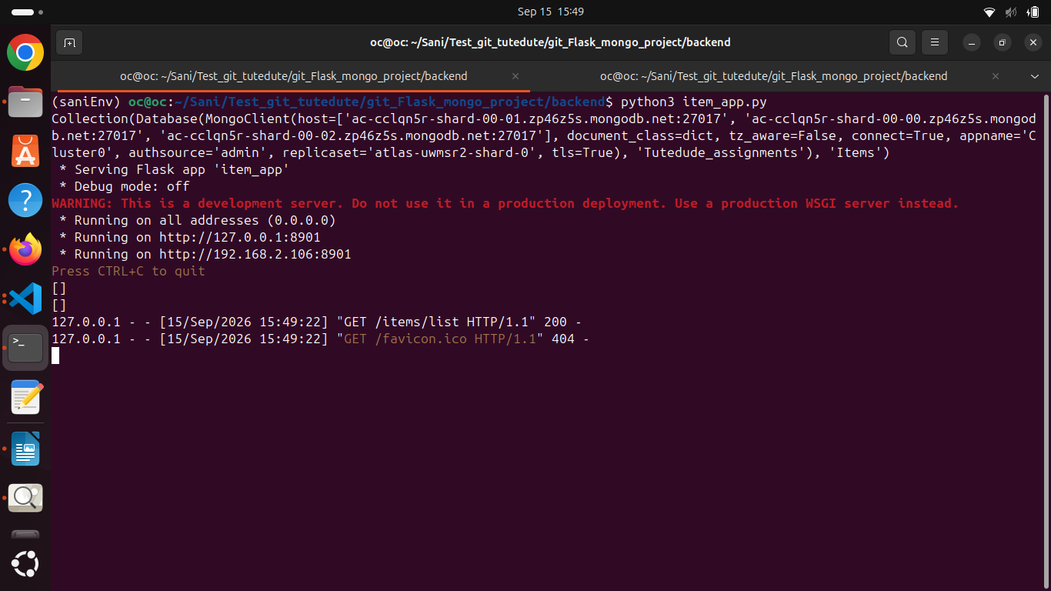
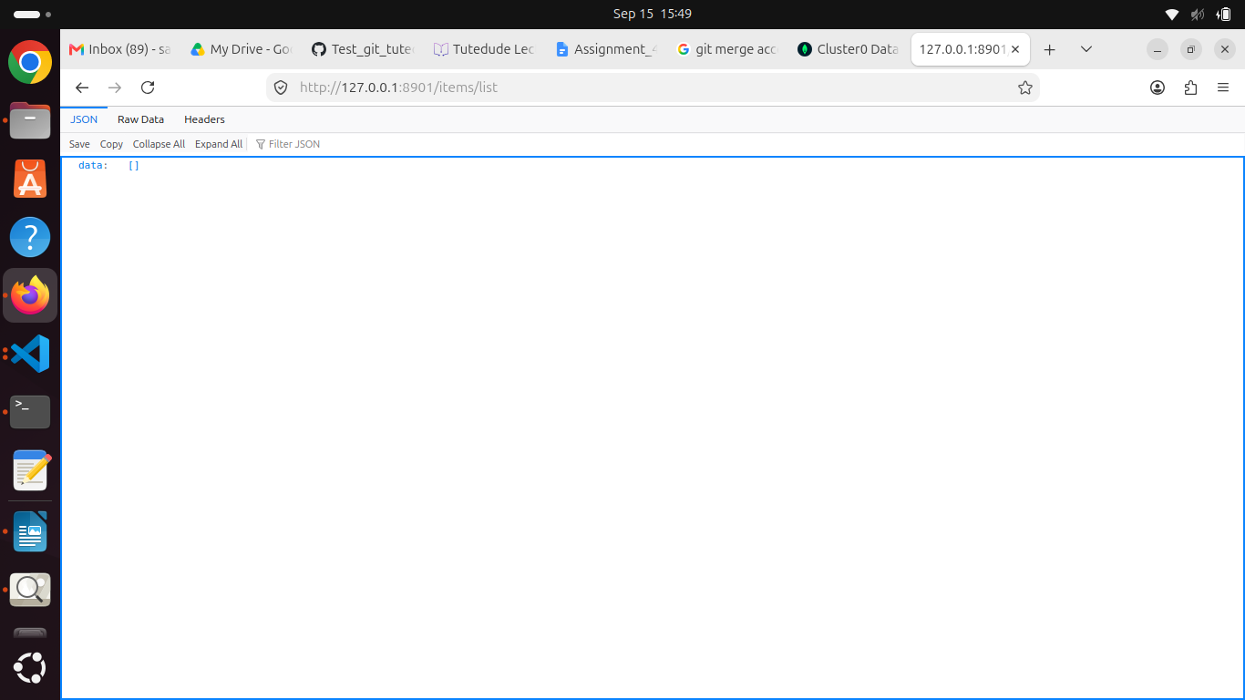
commit the backend changes in master_2
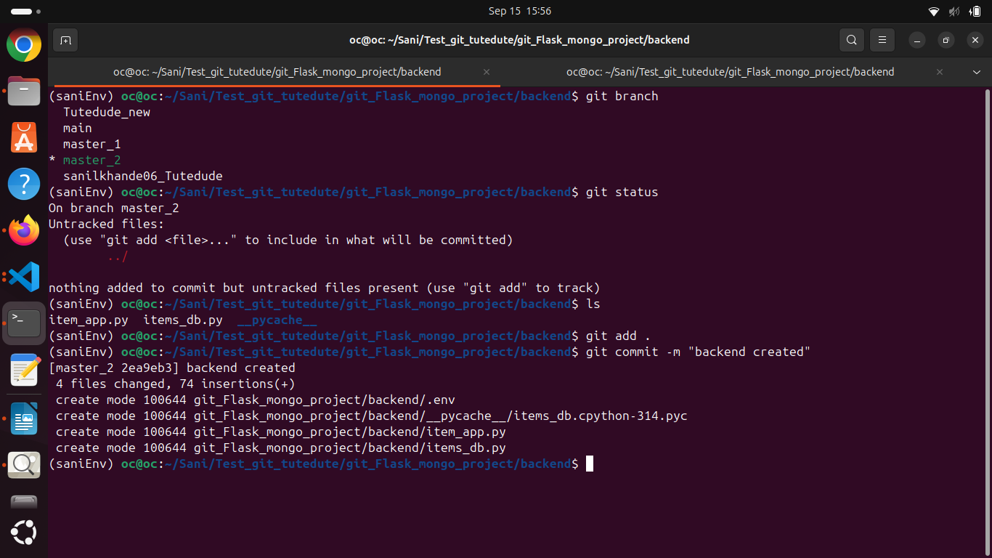

Merging master_1 and master_2 to main branches
git merge branch_name : used to merge the branch to main branch
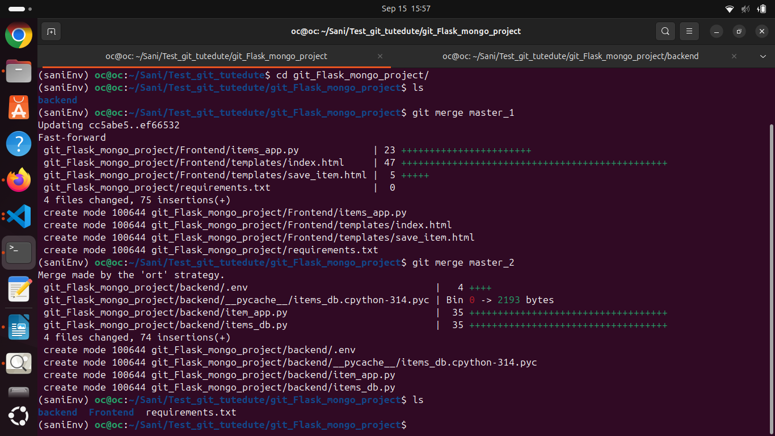
Running the application on main branch:
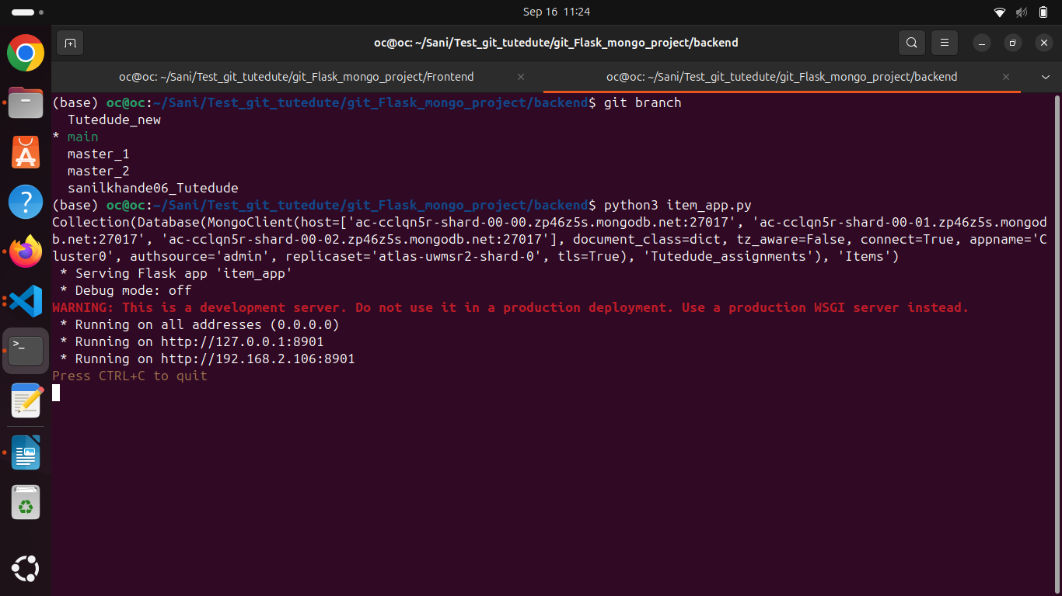
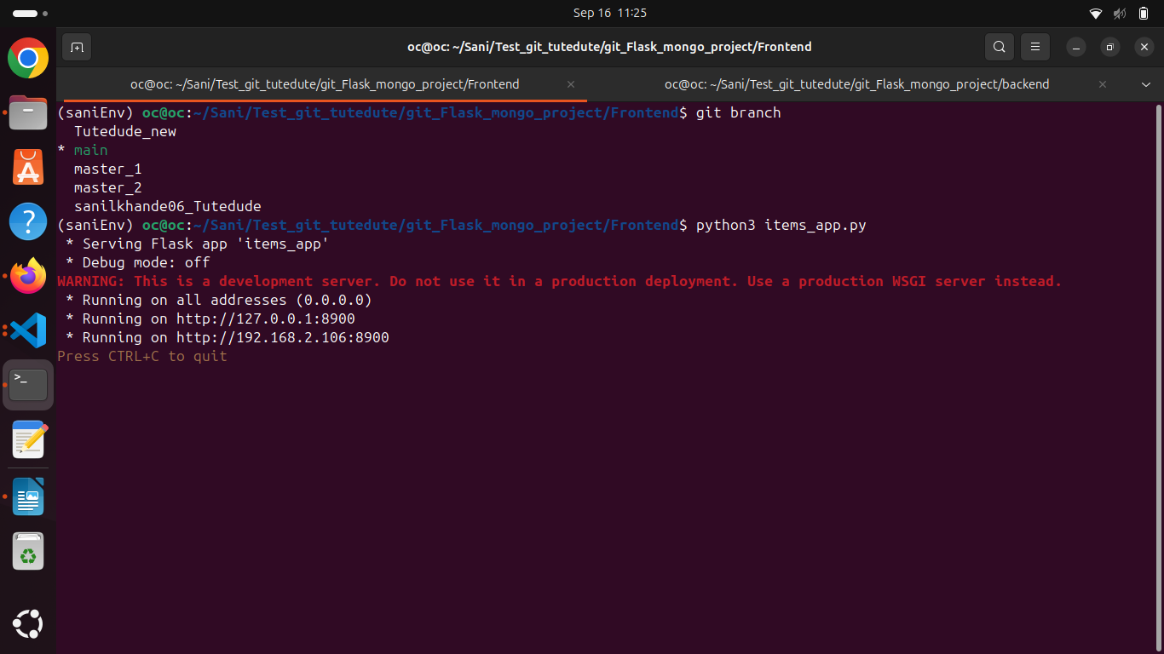
Form :
Saving the item :
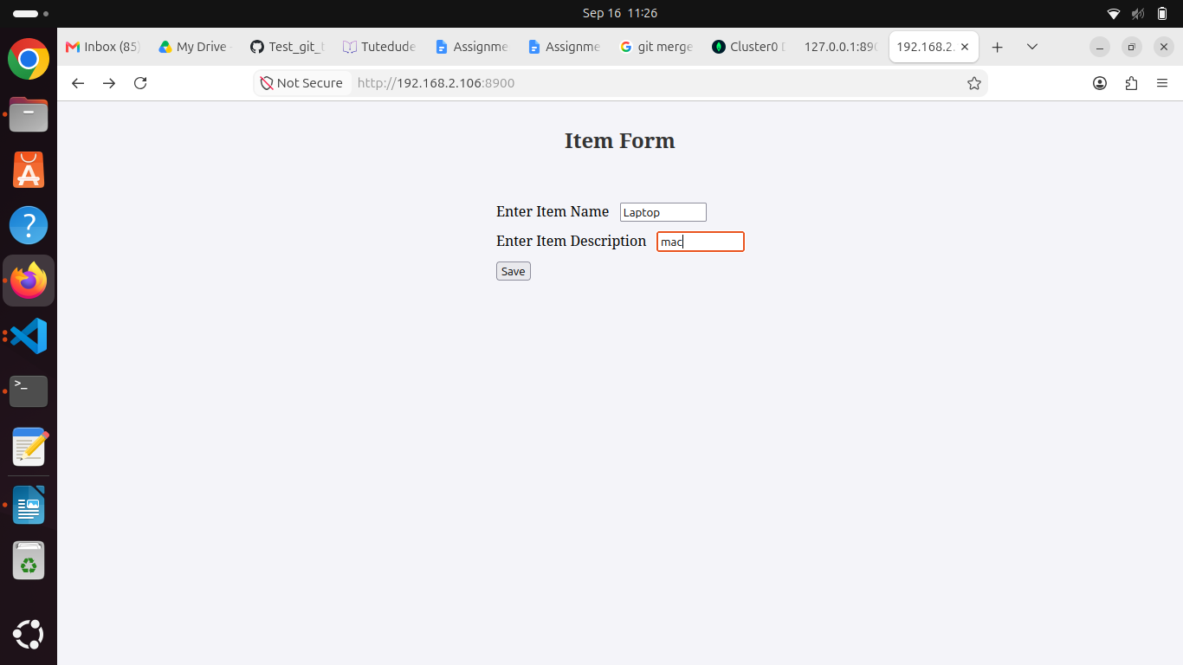
message after saving :
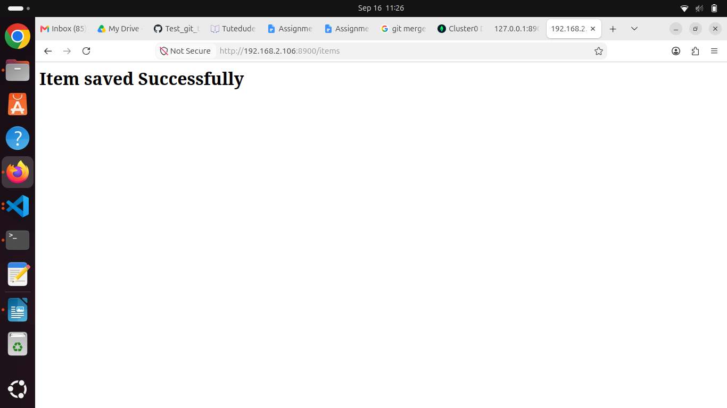
Listing the items from backend:
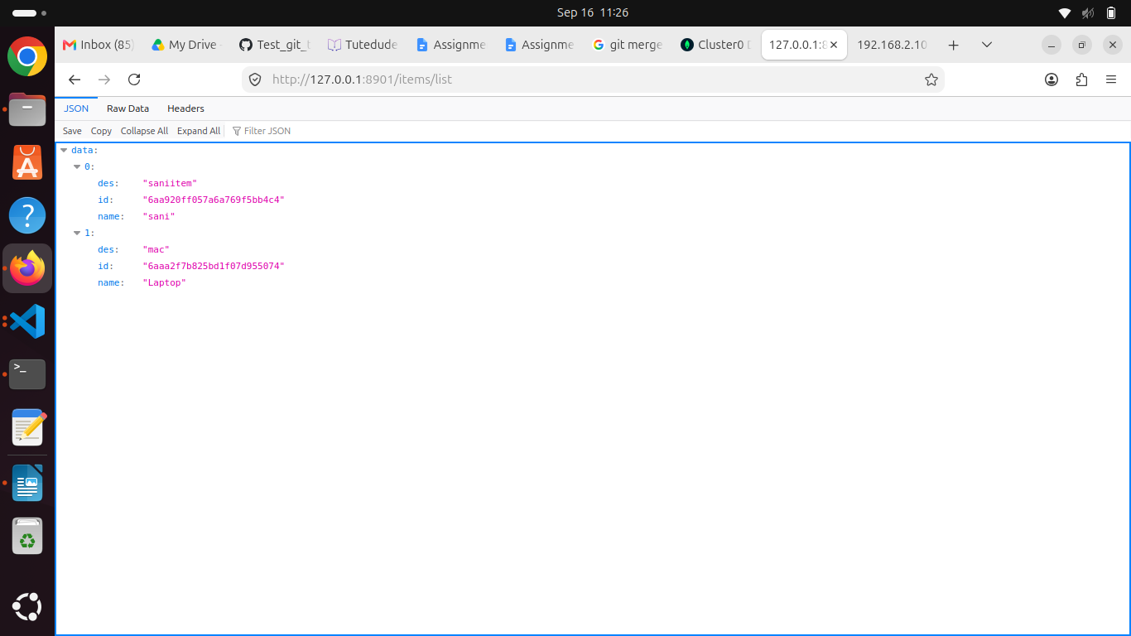

Items data in mongoDb
